Clean Code Principles - Organize Code by Actor (or Domain)
# Source: AI Source: Provided by: [Data Path: Persons Table -> ID Column: 1, Name_En Column: Motasem Essam] -> From: [Chatgpt (GPT‑5 Mini)] on [12/9/2025]
Organizing code by actor or domain means grouping code according to who uses it or which feature/domain it belongs to, rather than by technical layer alone.
👉 Makes your code easier to understand, navigate, and maintain, especially in large projects.

🔑 Why It Matters
# Source: AI Source: Provided by: [Data Path: Persons Table -> ID Column: 1, Name_En Column: Motasem Essam] -> From: [Chatgpt (GPT‑5 Mini)] on [12/9/2025]
- Improves project structure
- Makes it easier to find related classes
- Reduces confusion between unrelated functionality
- Encourages modular design

❌ Bad Example (Organized Only by Technical Layer)
# Source: AI Source: Provided by: [Data Path: Persons Table -> ID Column: 1, Name_En Column: Motasem Essam] -> From: [Chatgpt (GPT‑5 Mini)] on [12/9/2025]
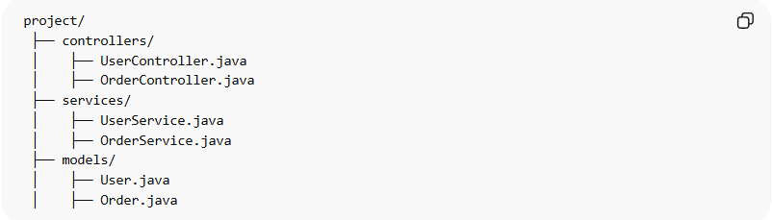
project/
├── controllers/
│ ├── UserController.java
│ ├── OrderController.java
├── services/
│ ├── UserService.java
│ ├── OrderService.java
├── models/
│ ├── User.java
│ ├── Order.java
👉 Problems:
- Files related to a single domain (e.g., "User") are scattered
- Harder to understand and maintain the "User" feature

✅ Good Example (Organized by Domain)
# Source: AI Source: Provided by: [Data Path: Persons Table -> ID Column: 1, Name_En Column: Motasem Essam] -> From: [Chatgpt (GPT‑5 Mini)] on [12/9/2025]
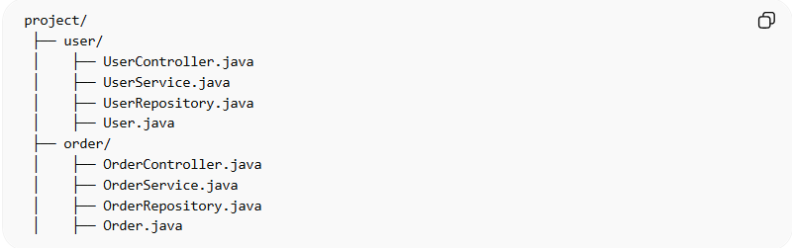
project/
├── user/
│ ├── UserController.java
│ ├── UserService.java
│ ├── UserRepository.java
│ ├── User.java
├── order/
│ ├── OrderController.java
│ ├── OrderService.java
│ ├── OrderRepository.java
│ ├── Order.java
✅ Benefits:
- Everything related to "User" or "Order" is grouped together
- Easier to understand, extend, and maintain
- Supports modular and feature-based development

💡 Key Idea
# Source: AI Source: Provided by: [Data Path: Persons Table -> ID Column: 1, Name_En Column: Motasem Essam] -> From: [Chatgpt (GPT‑5 Mini)] on [12/9/2025]
Group code by who uses it or which domain it belongs to, not just by technical layer, for clarity and maintainability.

🚫 Common Mistakes
# Source: AI Source: Provided by: [Data Path: Persons Table -> ID Column: 1, Name_En Column: Motasem Essam] -> From: [Chatgpt (GPT‑5 Mini)] on [12/9/2025]
- Organizing only by technical layer (controller, service, repository)
- Scattering domain-related code across multiple folders
- Making navigation confusing for developers

📦 Organize Code by Actor (or Domain) vs Organize Code Properly

1️⃣ Organize Code Properly
# Source: AI Source: Provided by: [Data Path: Persons Table -> ID Column: 1, Name_En Column: Motasem Essam] -> From: [Chatgpt (GPT‑5 Mini)] on [12/9/2025]
- Focus: general structure and readability
- Goal: Keep code well-structured, grouped logically, and easy to navigate
- Applies to:
  - Class structure within files
  - Folder hierarchy
  - Grouping related functions
- Example: Keeping UserService methods together, separating utility classes, using proper packages

2️⃣ Organize Code by Actor (or Domain)
# Source: AI Source: Provided by: [Data Path: Persons Table -> ID Column: 1, Name_En Column: Motasem Essam] -> From: [Chatgpt (GPT‑5 Mini)] on [12/9/2025]
- Focus: feature or domain-oriented organization
- Goal: Group code according to domain, feature, or “actor”, not just by technical type
- Applies to:
  - Grouping all User-related classes in a user/ folder
  - Grouping all Order-related classes in an order/ folder
- Example: Putting UserController, UserService, UserRepository, User.java in one user/ folder

🔑 Key Difference
# Source: AI Source: Provided by: [Data Path: Persons Table -> ID Column: 1, Name_En Column: Motasem Essam] -> From: [Chatgpt (GPT‑5 Mini)] on [12/9/2025]
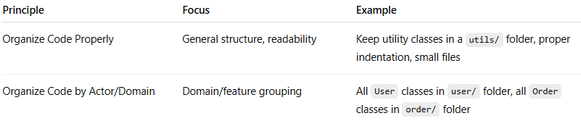
Principle | Focus | Example
Organize Code Properly | General structure, readability | Keep utility classes in a utils/ folder, proper indentation, small files
Organize Code by Actor/Domain | Domain/feature grouping | All User classes in user/ folder, all Order classes in order/ folder

✅ In short:
- “Organize Code Properly” is about overall structure and clarity
- “Organize Code by Actor/Domain” is a specific strategy to achieve good organization in larger projects

If you want, I can create a full Clean Code Principles list with all principles, plus good/bad examples so you have a single, complete reference. This will include both of these principles clearly separated.

🧾 Summary
# Source: AI Source: Provided by: [Data Path: Persons Table -> ID Column: 1, Name_En Column: Motasem Essam] -> From: [Chatgpt (GPT‑5 Mini)] on [12/9/2025]
Organizing code by actor/domain helps you:
- Find all related code in one place
- Improve maintainability and readability
- Support modular, scalable project design

